Date: 27/1/23

Course: Cloud Computing

Practical No : 1

Aim: Hands-on session of Cloud Analyst

Cloud Analyst is a tool developed at the University of Melbourne whose goal is to support evaluation of social networks tools according to geographic distribution of users and data centers.

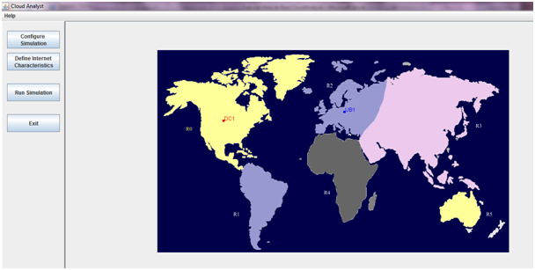

Important Keywords:-

Regions are based on the 6 main continents in the World.

User Base models a group of users that is considered as a single unit in the simulation and its main responsibility is to generate traffic for the simulation.

DataCenter management activities will be VM creation and destruction and does the routing of user requests received from User Bases via the Internet to the VMs.

Service broker policy:

VM management and routing traffic to appropriate data centers.

* Closest data center – The data center with the least network latency (disregarding network bandwidth) from a particular user base is sent all the requests from that user base.
* Optimize response time – This policy attempts to balance the load between data centers when one data center gets over loaded.
* Dynamically reconfiguring: taking under consideration the current processing times and best processing time ever achieved.

Load balancing policy:

Used by all data centres in allocating requests to virtual machines.

* Round-robin Load Balancer – uses a simple round-robin algorithm to allocate VMs.
* Active Monitoring Load Balancer –load balances the tasks among available VM's in a way to even out the number of active tasks on each VM at any given time (server consolidation).
* Throttled Load Balancer – this ensures only a pre-defined number of Internet Cloudlets are allocated to a single VM at any given time and some of the requests will have to be queued until the next VM becomes available.

Configure Simulation :

For Configuring stimulator :

1. Main Configuration

2. Data center Configuration

3. Advanced

1. Main Configuration :

It consist of simulation duration , user base configuration , service broker policy .

User Base Configuration : We can add and remove User Base and divide them into different regions

Service broker policy : there are three types of Service broker policy

1.Closest Data Center

2.Optimise Response Time

3. Reconfigure Dynamically with load balancer

2.Data center Configuration :

We can add and remove data centers and divide them into different regions .

3.Advanced

It consist of grouping factor of user base , request grouping factor in data centers , length per

request , Load balancing policies .

Load Balancing Policies :

1.Round Robin

2.Equally Spread Current Execution Load

3.Throttled

Define Internet Characteristics :

we can Configure internet characteristics like Delay matrix and Bandwidth matrix .

Run Simulation : to Generate the Analysis Reports

Results:

1. Closest data center service broker policy and Round-robin Load Balancer

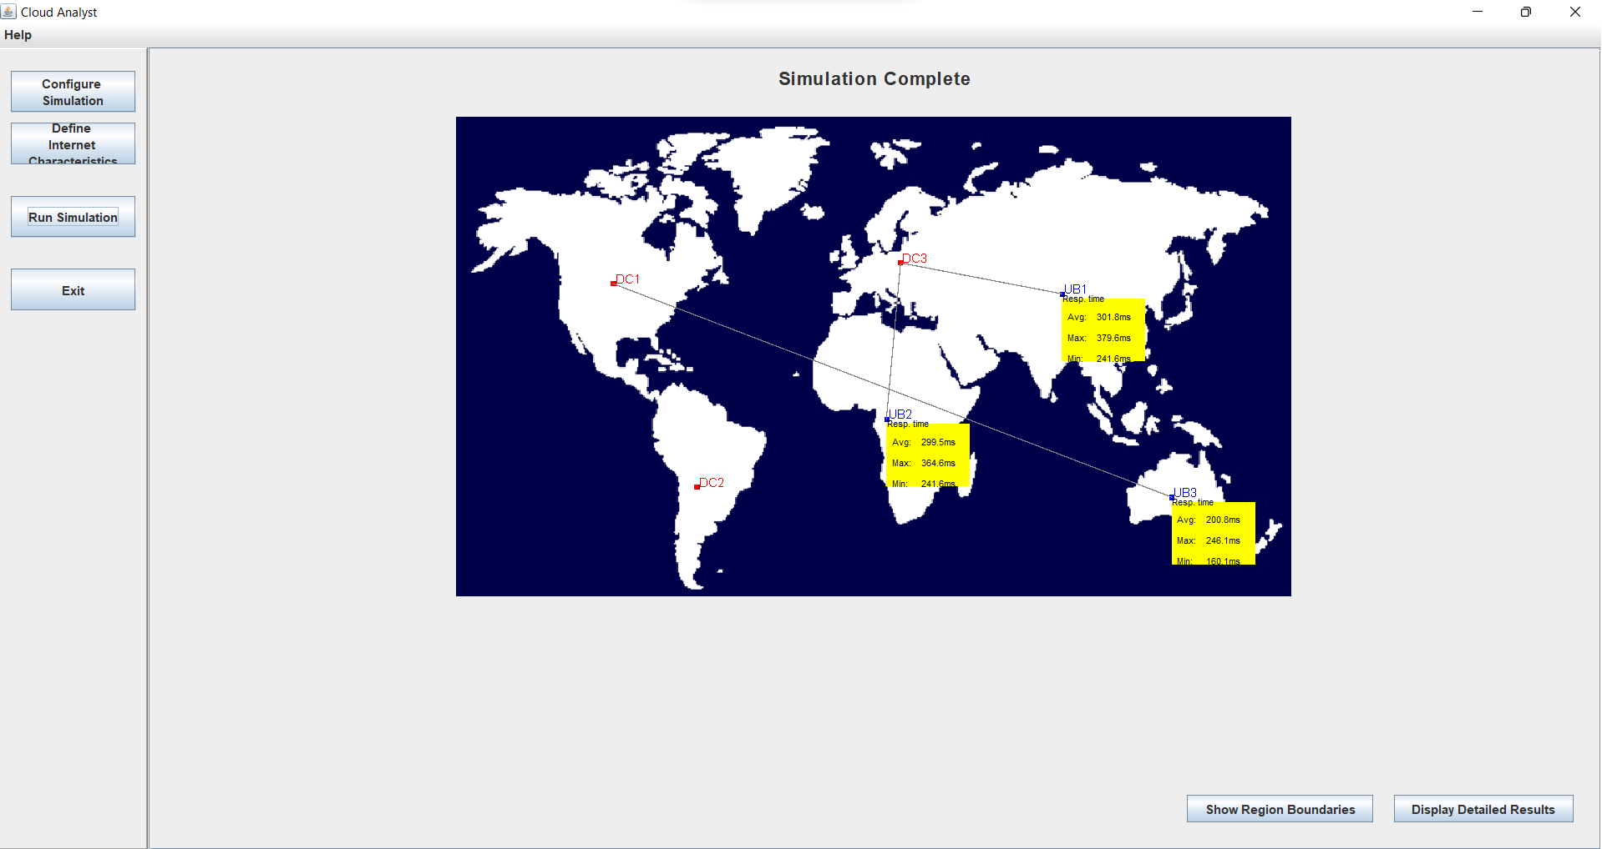

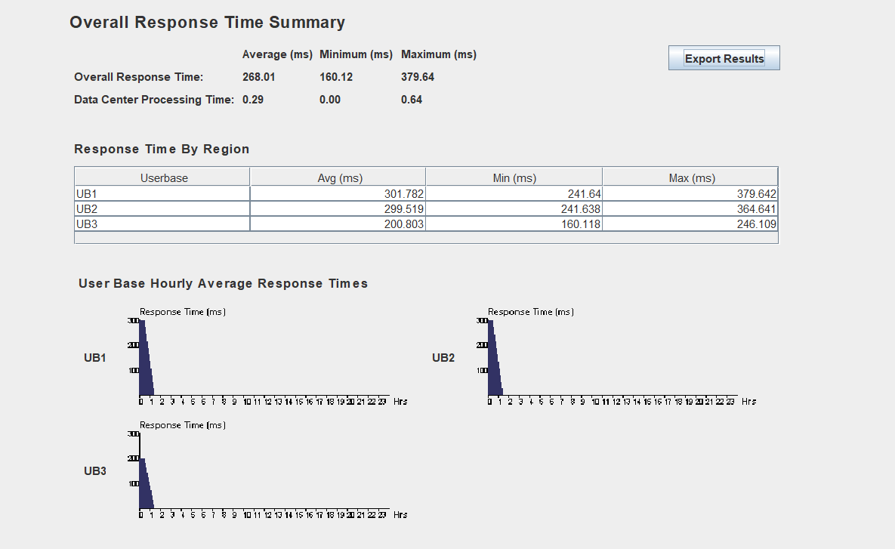

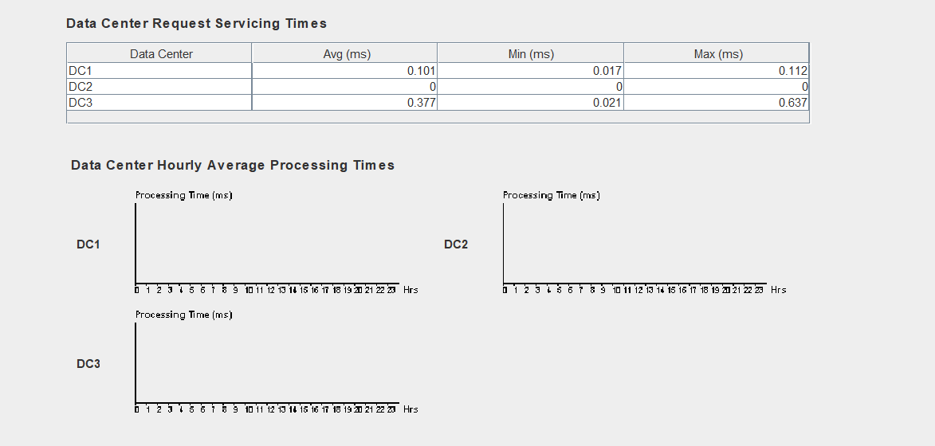

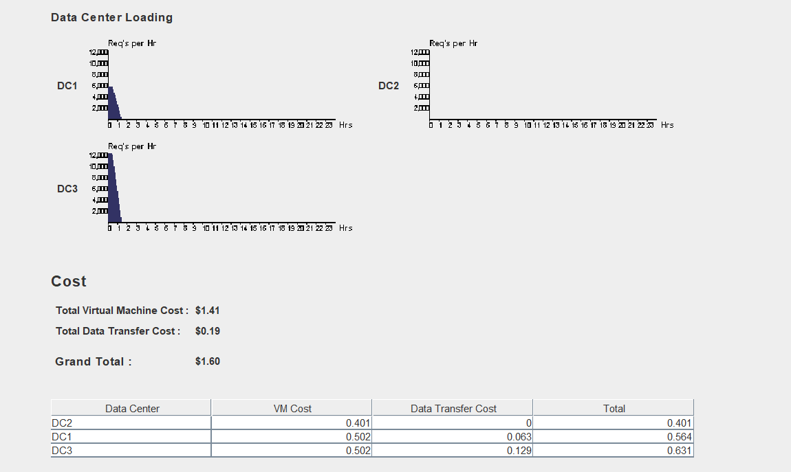

1. Closest data center service broker policy and Equally Spread Current Execution Load

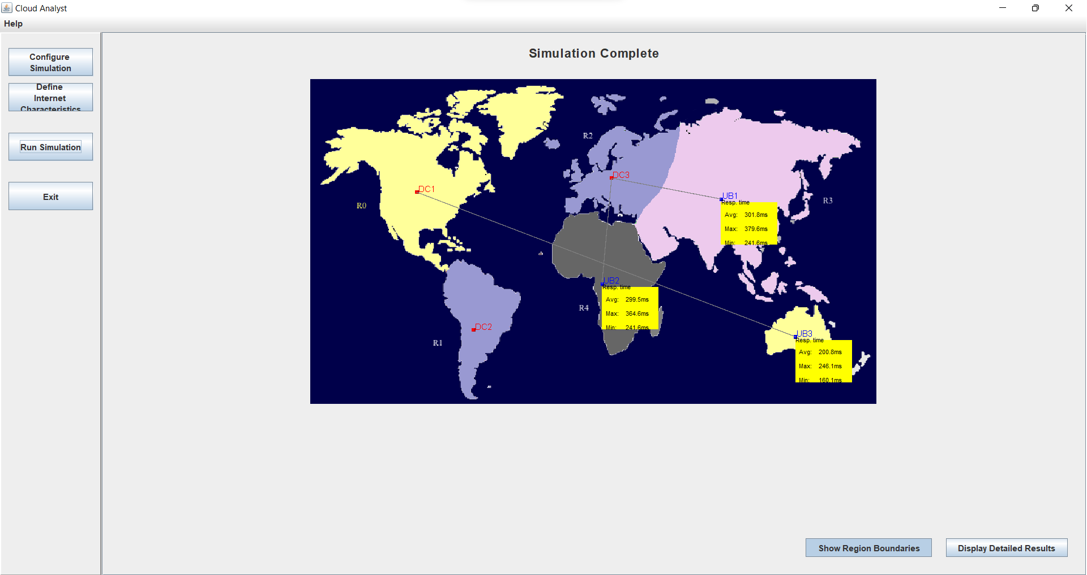

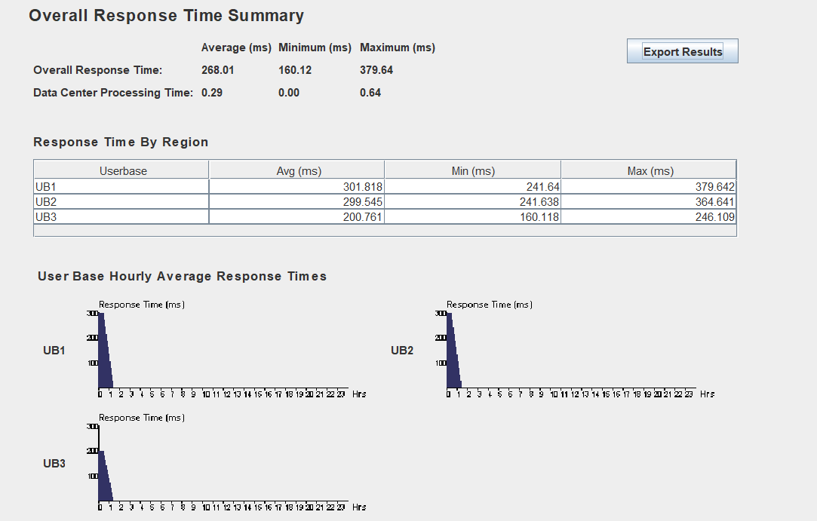

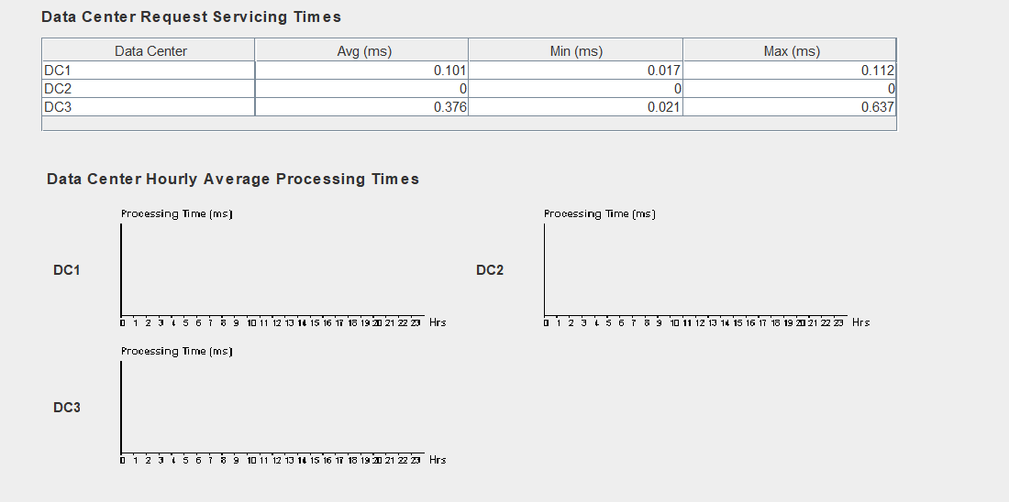

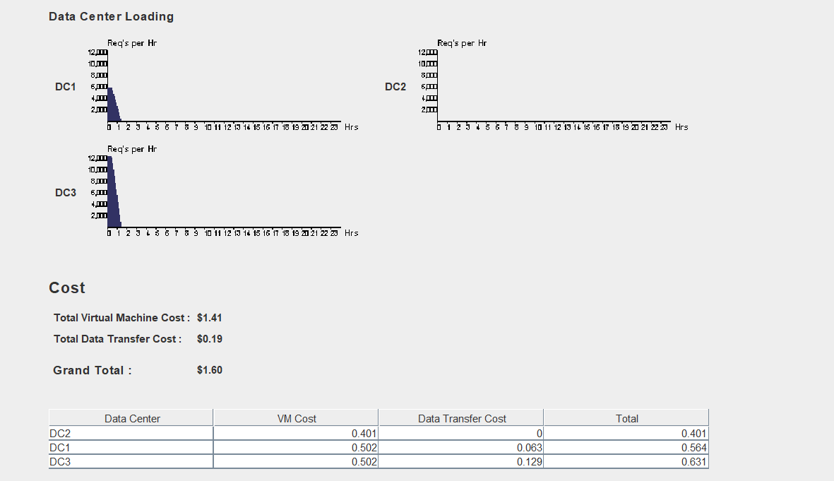

1. Closest data center service broker policy and Throttled Load Balancer

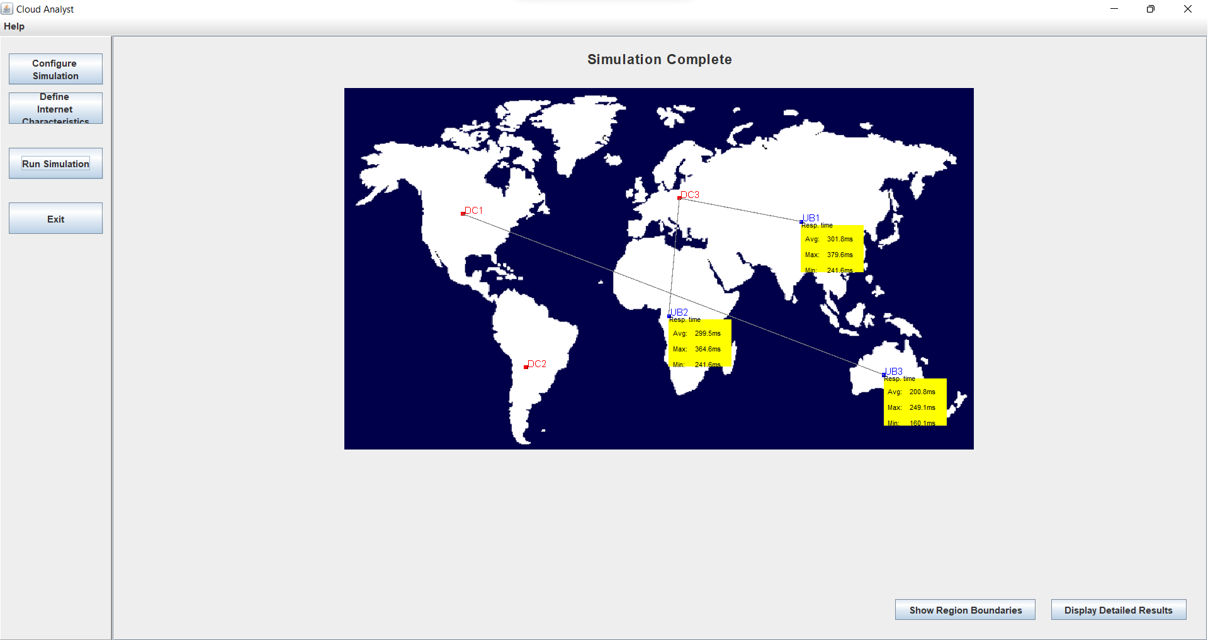

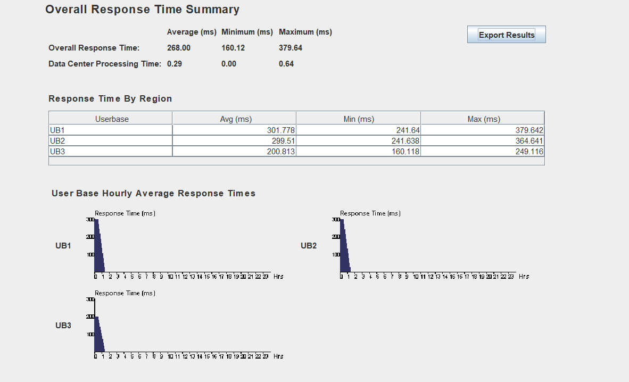

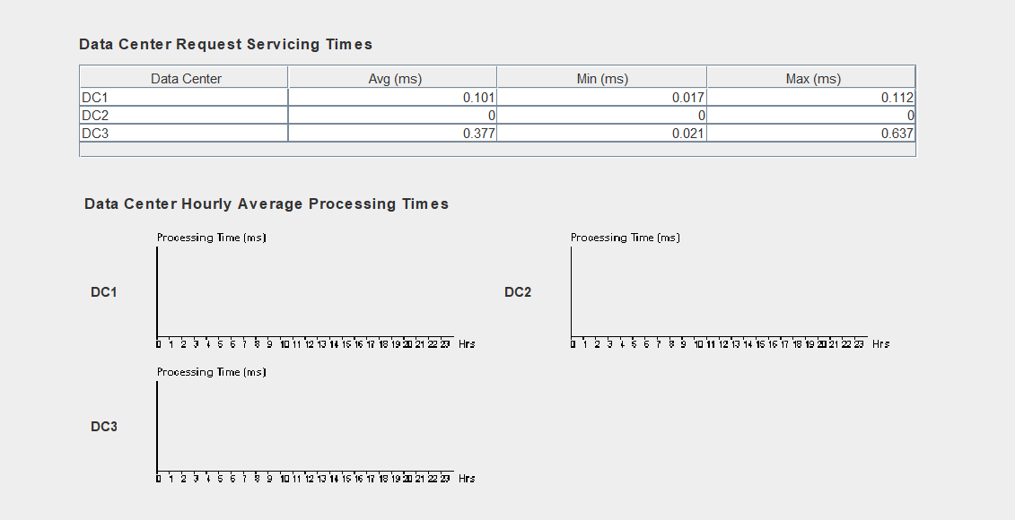

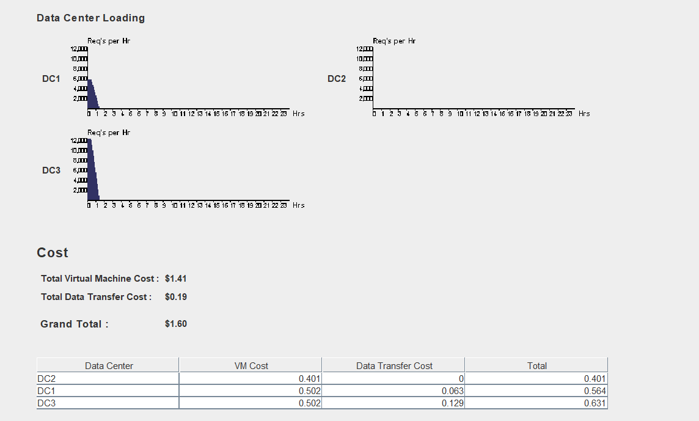

1. Optimize response time service broker policy and Round-robin Load Balancer

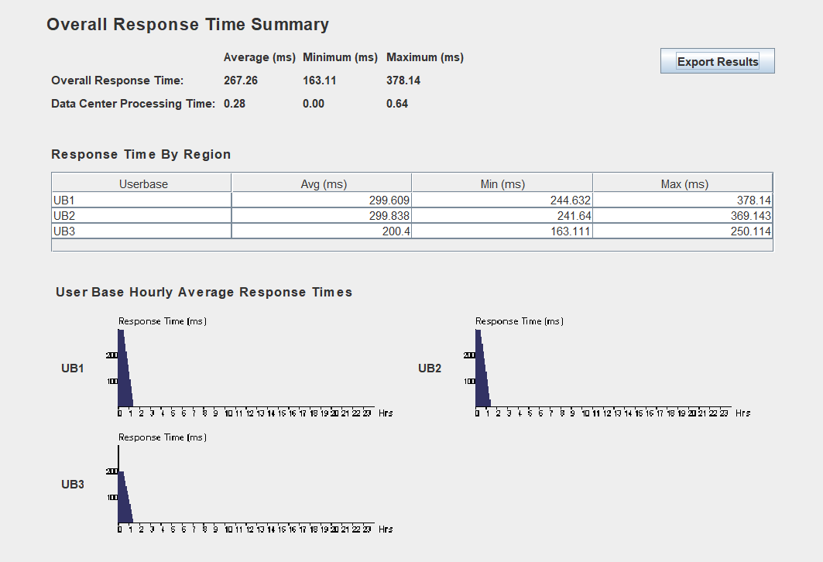

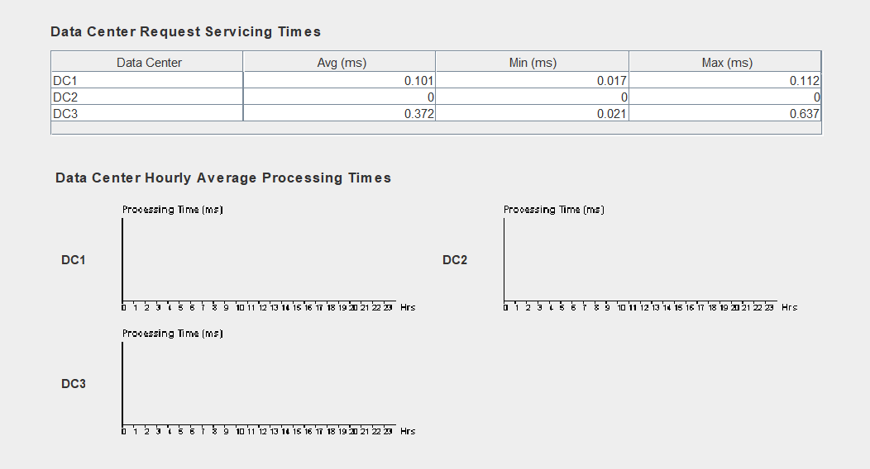

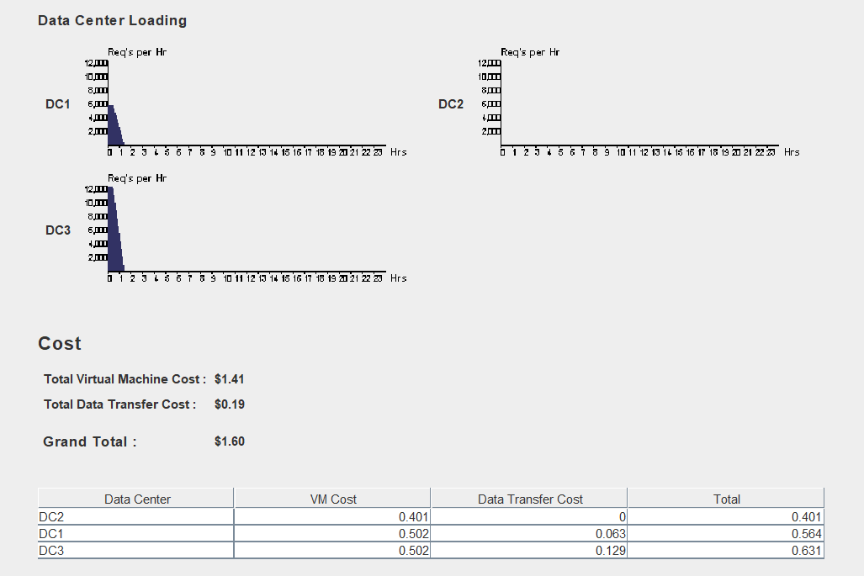

1. Optimize response time service broker policy and Equally Spread Current Execution Load

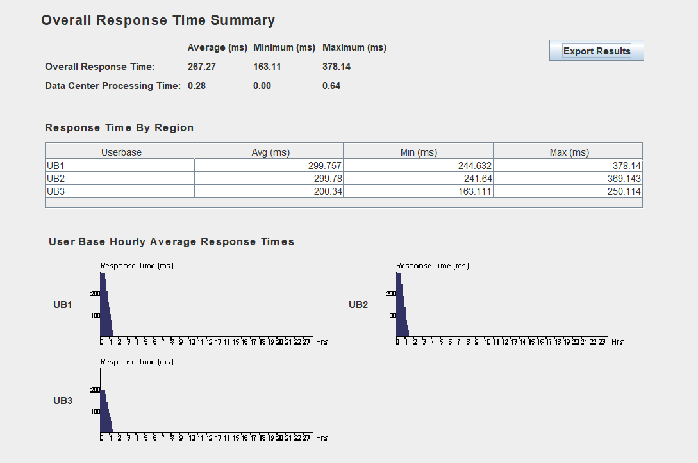

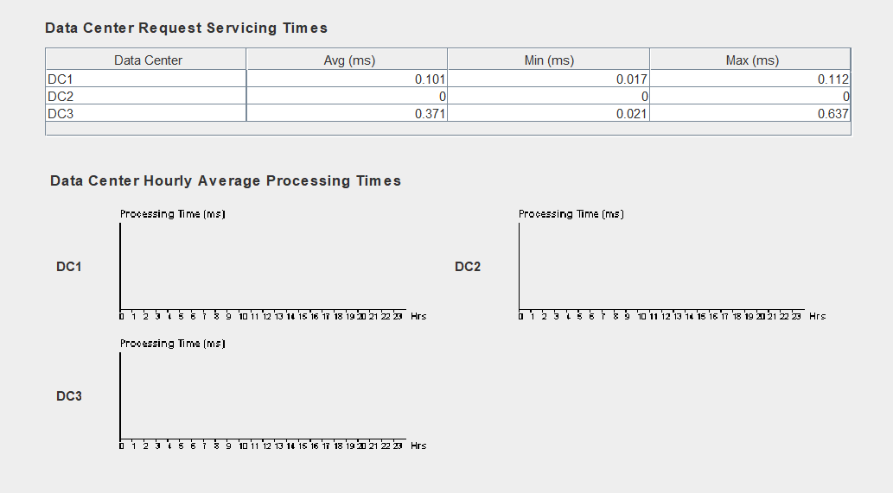

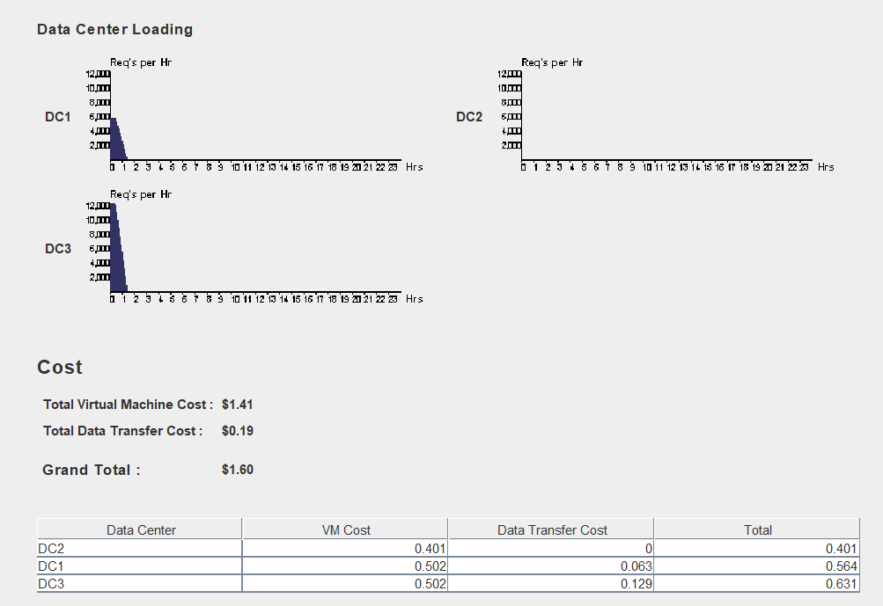

1. Optimize response time service broker policy and Throttled Load Balancer

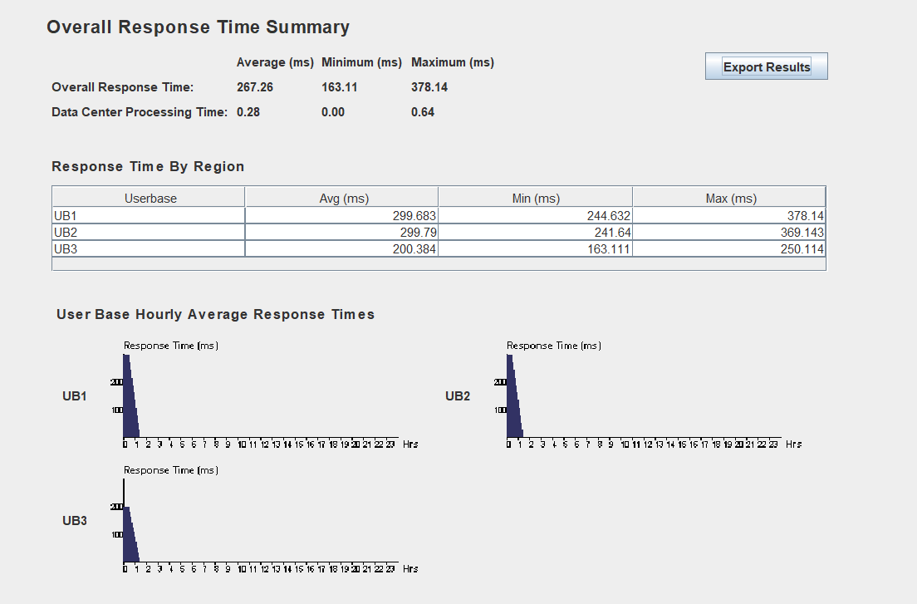

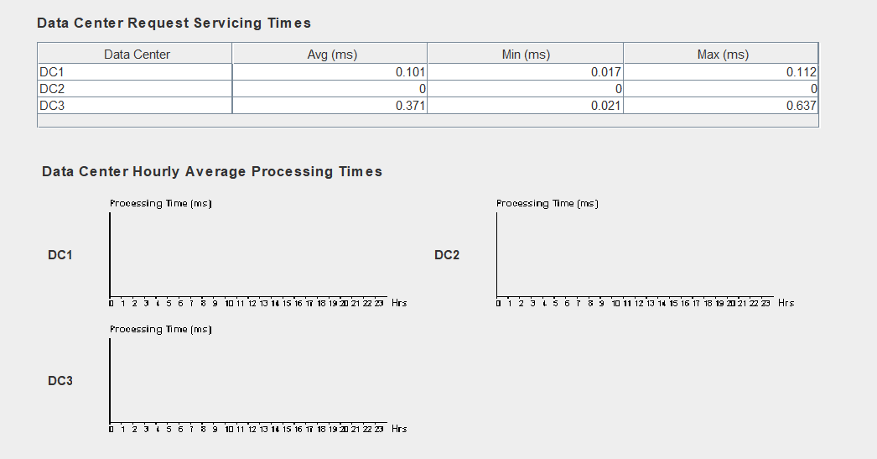

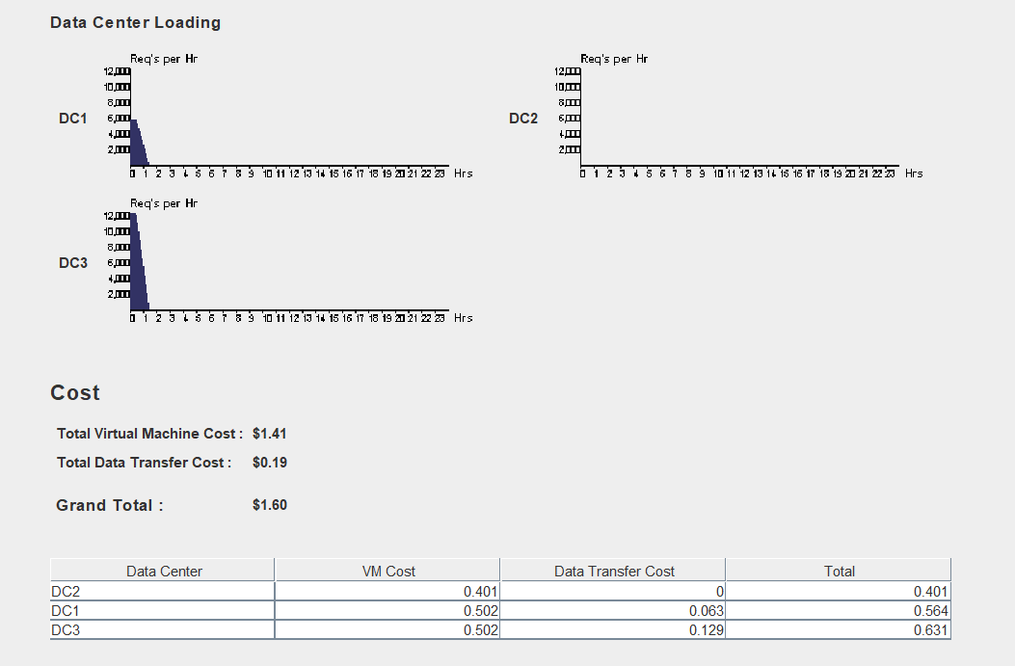

1. Dynamically reconfiguring service broker policy and Round-robin Load Balancer

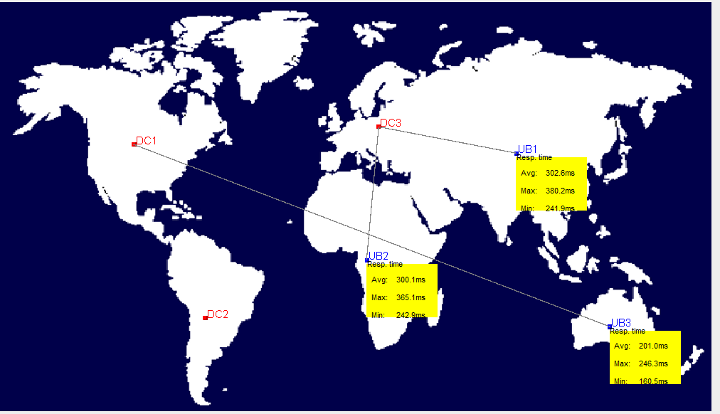

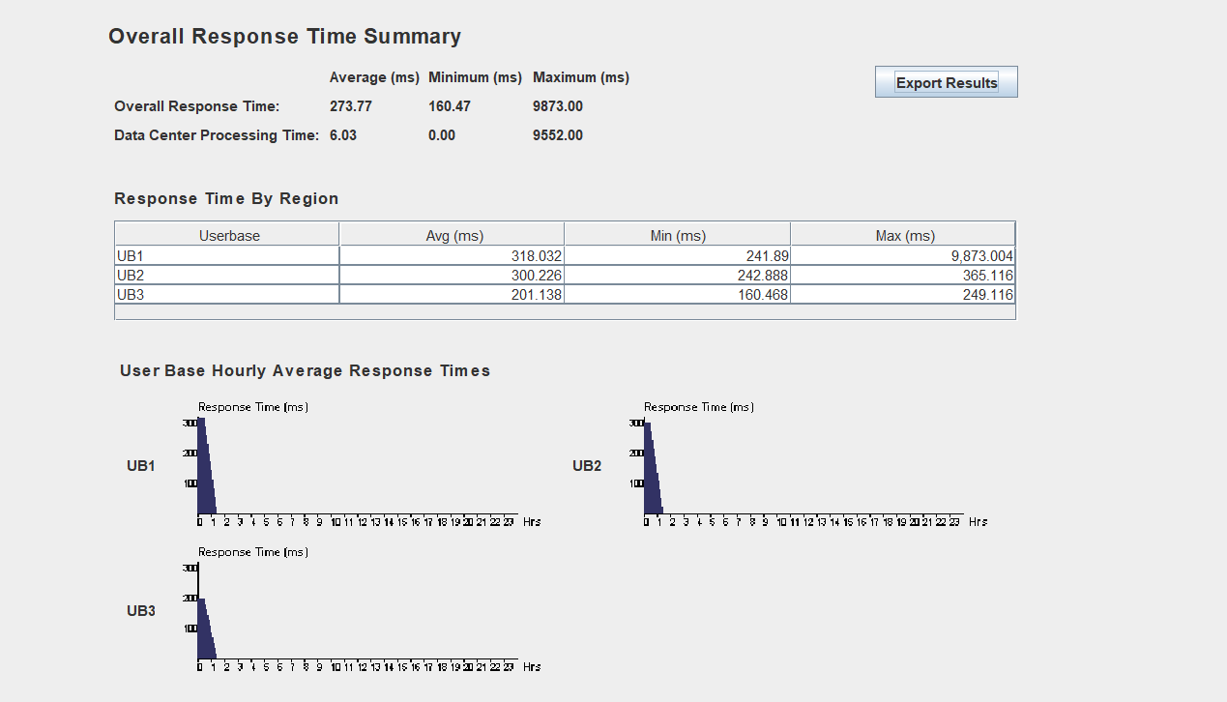

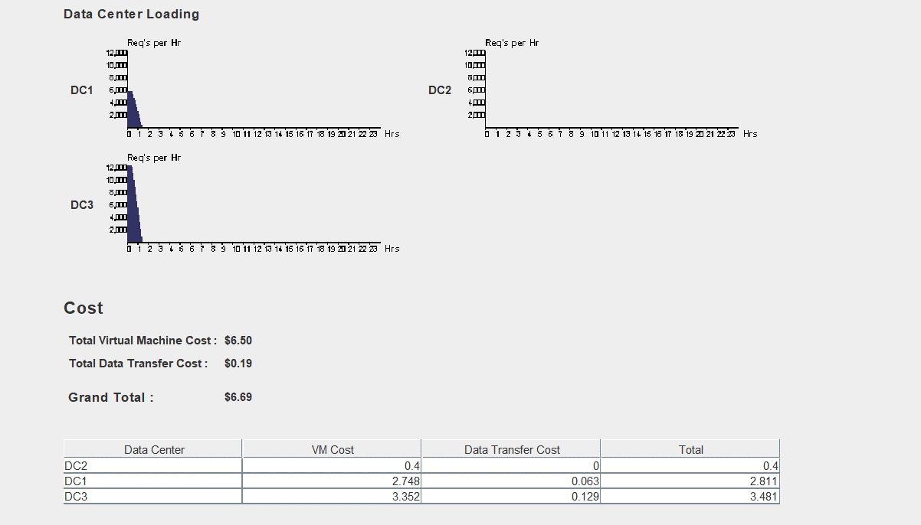

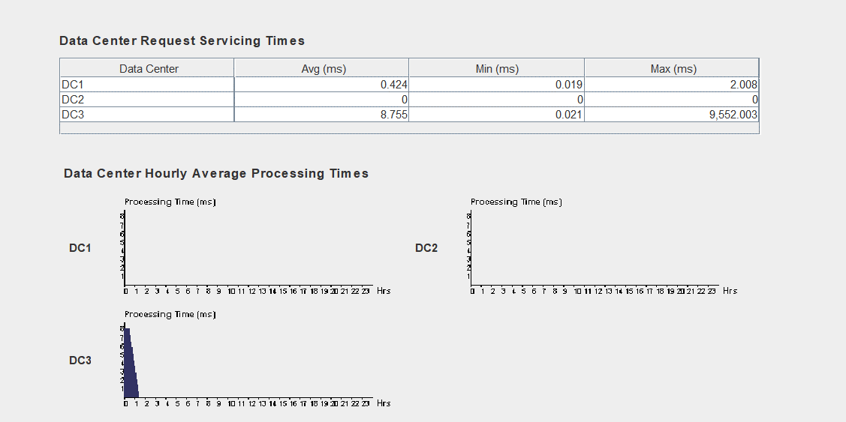

1. Dynamically reconfiguring service broker policy and Equally Spread Current Execution Load

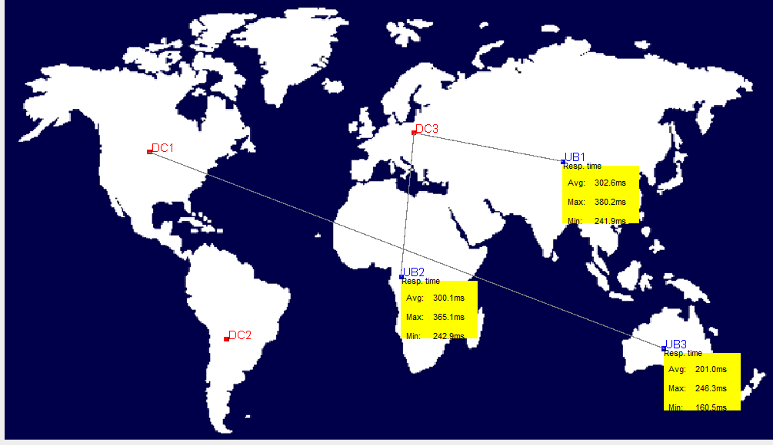

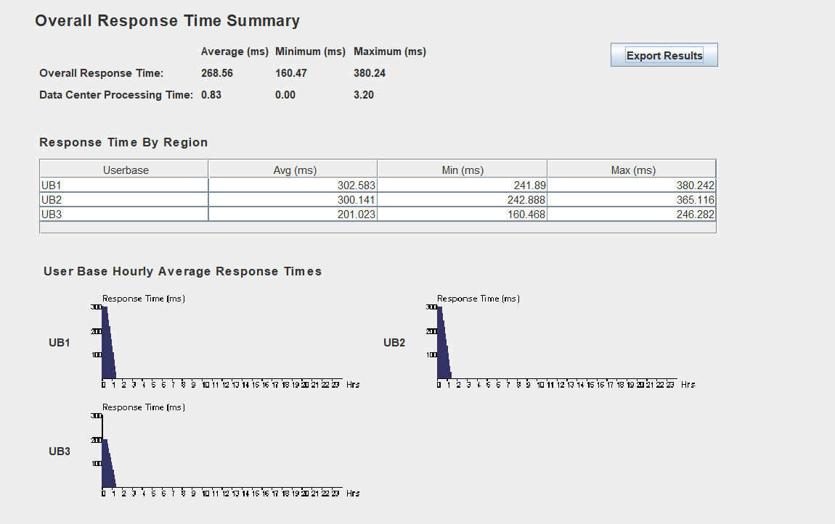

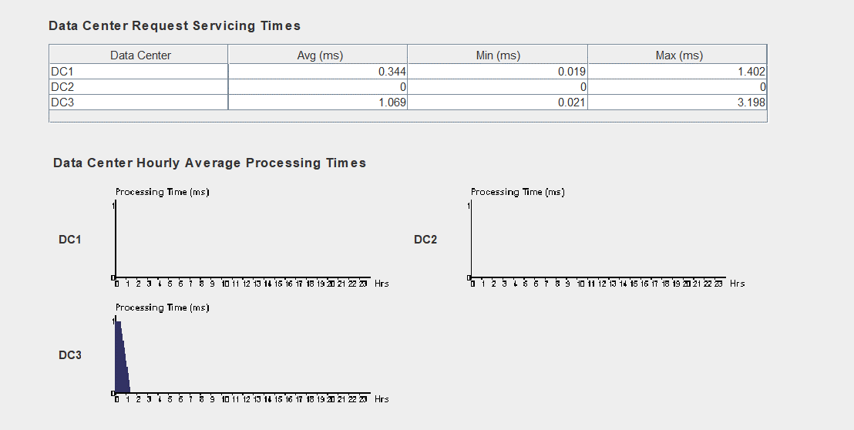

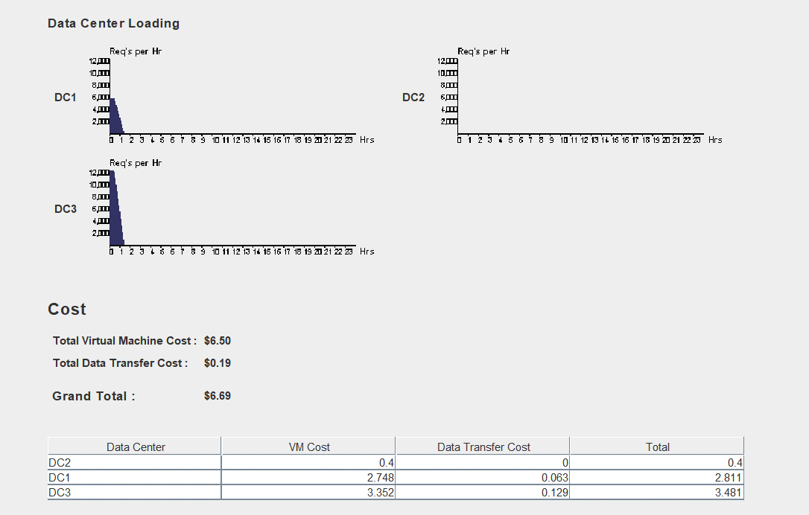

1. Dynamically reconfiguring service broker policy and Throttled Load Balancer



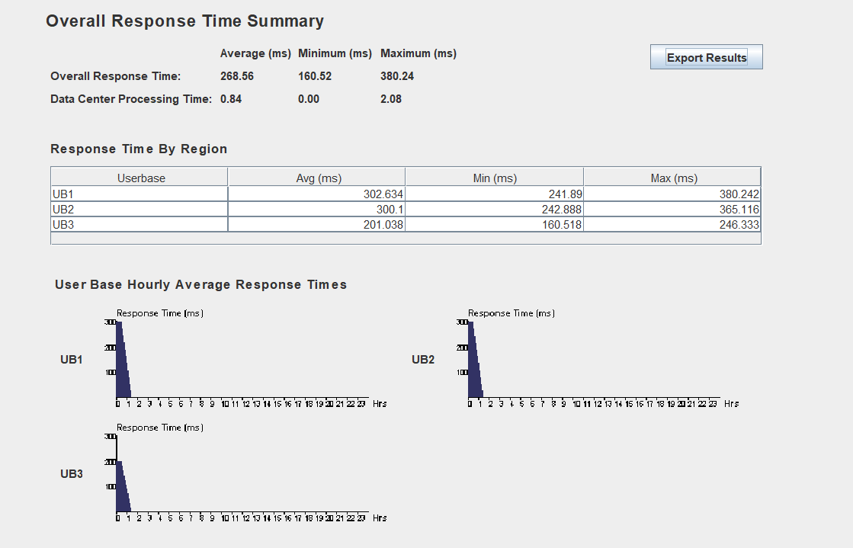

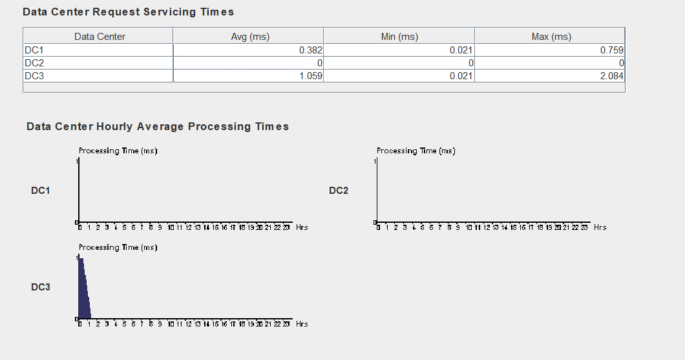

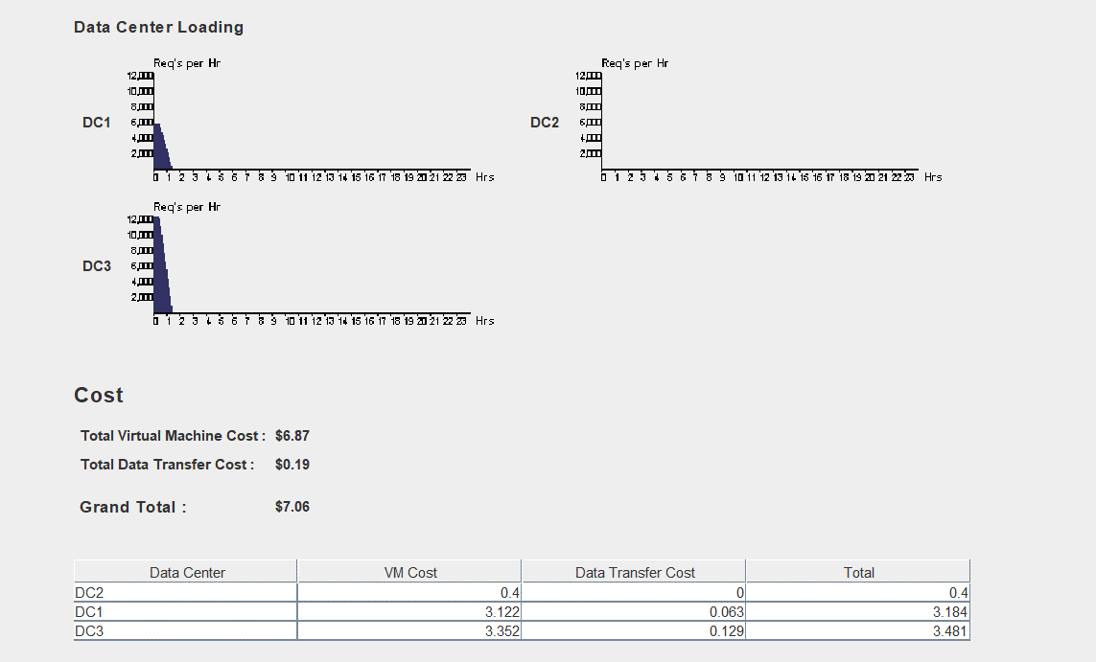

Analysis:

There is a difference in all the parameters by using all the three service broker policies. They are as follows:

|  |  |  |  |  |  |
| --- | --- | --- | --- | --- | --- |
| **Sr no** | **load balancing policy** | **service broker policy** | **Avg Overall response time(ms)** | **Avg Data center processing time**  **(ms)** | **Grand total cost**  **($)** |
| 1 | **Round Robin** | **Closest Data Center** | 268.01 | 0.29 | 1.60 |
| 2 | **Optimise Response Time** | 267.26 | 0.29 | 1.60 |
| 3 | **Reconfigure Dynamically** | 273.77 | 0.29 | 1.60 |
| 4 | **Equally Spread Current Execution Load** | **Closest Data Center** | 268.01 | 0.28 | 1.60 |
| 5 | **Optimise Response Time** | 267.27 | 0.28 | 1.60 |
| 6 | **Reconfigure Dynamically** | 268.56 | 0.28 | 1.60 |
| 7 | **Throttled** | **Closest Data Center** | 268.00 | 6.03 | 6.69 |
| 8 | **Optimise Response Time** | 267.26 | 0.83 | 6.69 |
| 9 | **Reconfigure Dynamically** | 268.56 | 0.84 | 7.06 |

The Average time required for servicing a request or the data center processing time is less for the **“Optimise response time”** broker policy as compared to other broker policy.

So, it is clear on the basis of comparison the **“Optimise Response Time” broker policy is more efficient on the basis of its performance.**

When the user base load is the same, performance of all load

balancing policies will be the same.

And when the datacenter load balancing policies are dynamically

configured, round-robin performs poorly with respect to Active Monitoring

and Throttled.

Conclusion:

CloudAnalyst is a new tool developed to address this need, based on top of mature simulation frameworks such as SimJava, GridSim and CloudSim. We described the design of the CloudAnalyst in detail and explained the various algorithms used in different scenarios. Currently it is the first step of a tool and an approach to studying this type of applications by simulation, and the tool and the approach is expected to evolve over the time producing improved quality of analysis along the way.